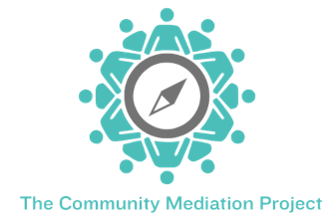
Become a Mediator or

TCMP Operations Volunteer

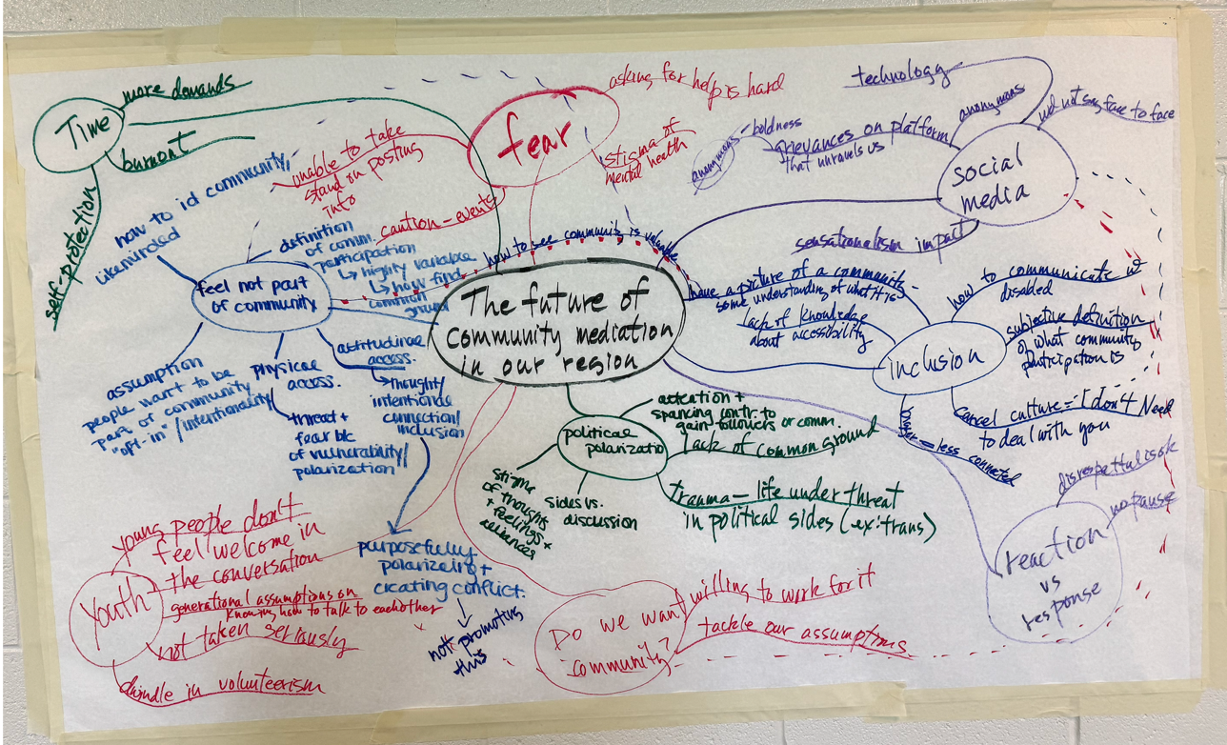
Insights from our community in 2025 that is the foundation of our work.

TCMP mediators and volunteers help people have difficult conversations on participants’ own terms. Our training is based on the transformative framework of conflict intervention.

Mediators learn to

- Understand conflict as a crisis in human interaction
- Listen well and deeply to what people are saying
- Reflect and summarize what they hear, helping people hear themselves and each other
- Ask open questions to help people explore their thinking, options, and decision-making.
- Facilitate conversation for those caught in conflict to help them make the best decisions they can, given the situation they face, and the perspectives of others involved.
What to Expect

TCMP community mediators undergo an initial 40-hour training, which is spread over two weekends. After you successfully complete mediator training, you will become an apprentice mediator. You will observe at least two mediations, then you will be paired with an experienced mediator/coach to conduct two to three mediations. Upon completing your apprenticeship, you can mediate with any of our trained mediators.
​
When mediators make a commitment to volunteer for at least two years, the training is free. Volunteers can mediate, facilitate workshops, or support operations. We offer mediation training to others, as space permits, for a fee of $1200, and offer training to community partners at a reduced rate.

Roles that require 40-hour mediator training

Mediation Mediators support custody mediations, meetings for families in crisis, neighbor disputes, and other types of cases.

Facilitation Assist TCMP facilitators to conduct training or dialogue facilitation, working with groups.

Role that does not require 40-hour mediator training

Operations You can also support our operations, conducting intake and outreach—both excellent ways to learn, participate, and contribute.
- Complete intake questionnaires for participants seeking mediation. Explain the process, collect data, and coordinate schedules.
- Assist with outreach and logistics for workshops and community dialogues.
Note: Operations volunteers are invited to participate in our mediator continuing education.

Being an active mediator

To remain a mediator in good standing with TCMP, the following ongoing requirements must be met
​
- A mediator must be willing to be available for one to two mediation assignments each month. Most cases are co-mediated. A workshop facilitation can be substituted for a mediation.

- A mediator must participate in continuing education, as available through TCMP, and attend at least three workshops or trainings each year.

- Advanced training may be offered periodically, and mediators are expected to participate. This may include ethics training, deeper knowledge of custody issues, family crisis issues, IEP support, and more.

http://tcmp-pa.org 215-348-4174

